***K8-P1***

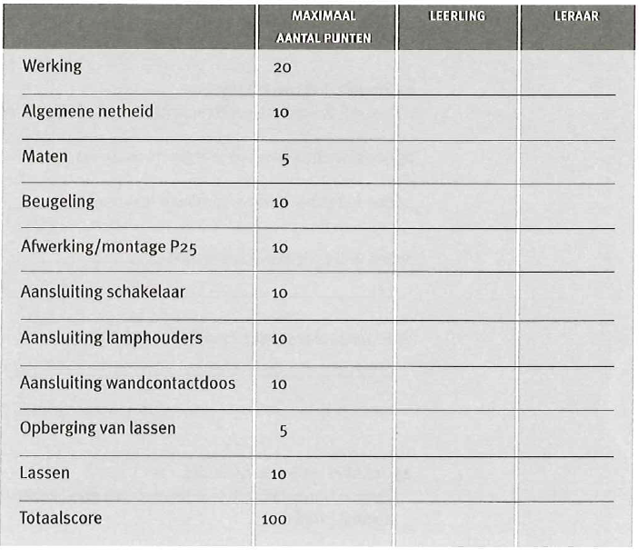Naam 1:_________________________________

Naam 2:_________________________________